**Practical No. 4**

**Aim:** Programs related to different Layouts

1. Coordinate
2. Linear
3. Relative
4. Table
5. Absolute
6. Frame
7. **Coordinate Layout:**

**activity_main.xml:**

<?xml version="1.0" encoding="utf-8"?>  
<androidx.coordinatorlayout.widget.CoordinatorLayout  
 xmlns:android="http://schemas.android.com/apk/res/android"  
 xmlns:app="http://schemas.android.com/apk/res-auto"  
 xmlns:tools="http://schemas.android.com/tools"  
 android:layout_width="match_parent"  
 android:layout_height="match_parent"  
 tools:context=".MainActivity">  
<EditText  
 android:layout_width="wrap_content"  
 android:layout_height="wrap_content"  
 android:layout_marginStart="117dp"  
 android:layout_marginLeft="117dp"  
 android:layout_marginTop="342dp"  
 android:ems="10"  
 android:inputType="textPersonName"  
 android:hint="Enter Name"  
 android:id="@+id/e1"  
 android:height="50dp"  
 android:gravity="center"  
 app:layout_constraintStart_toStartOf="parent"  
 app:layout_constraintTop_toTopOf="parent" />  
</androidx.coordinatorlayout.widget.CoordinatorLayout>

**MainActivity.kt:**

package com.example.layoutdemo  
import androidx.appcompat.app.AppCompatActivity  
import android.os.Bundle  
class MainActivity : AppCompatActivity() {  
 override fun onCreate(savedInstanceState: Bundle?) {  
 super.onCreate(savedInstanceState)  
 setContentView(R.layout.activity_main)  
 }  
}

**Output:**

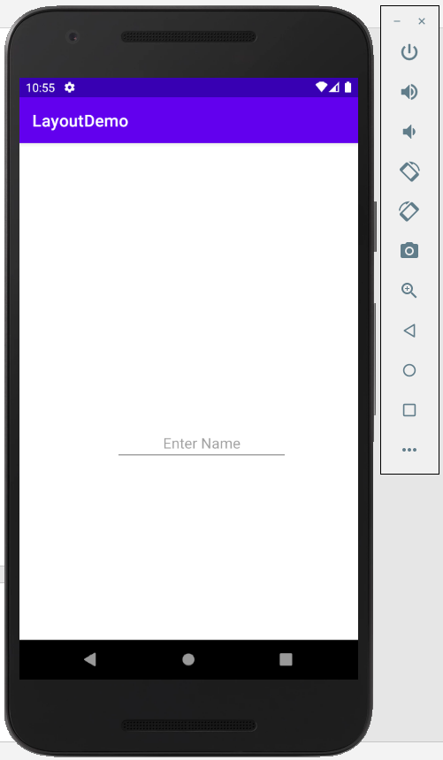

1. **Linear Layout:**

**activity_main.xml:**

<?xml version="1.0" encoding="utf-8"?>  
<androidx.appcompat.widget.LinearLayoutCompat  
 xmlns:android="http://schemas.android.com/apk/res/android"  
 xmlns:app="http://schemas.android.com/apk/res-auto"  
 xmlns:tools="http://schemas.android.com/tools"  
 android:layout_width="match_parent"  
 android:layout_height="match_parent"  
 android:orientation="vertical"  
 tools:context=".MainActivity">  
 <TextView  
 android:layout_marginTop="20dp"  
 android:id="@+id/textView"  
 android:layout_width="wrap_content"  
 android:layout_height="wrap_content"  
 android:text="Enter a number" />  
 <LinearLayout  
 android:layout_width="wrap_content"  
 android:layout_height="wrap_content">  
 <Button  
 android:id="@+id/b1"  
 android:layout_width="wrap_content"  
 android:layout_height="wrap_content"  
 android:text="1" />  
<Button  
 android:id="@+id/b2"  
 android:layout_width="wrap_content"  
 android:layout_height="wrap_content"  
 android:text="2" />  
<Button  
 android:id="@+id/b3"  
 android:layout_width="wrap_content"  
 android:layout_height="wrap_content"  
 android:text="3" />  
 <Button  
 android:id="@+id/bs"  
 android:layout_width="wrap_content"  
 android:layout_height="wrap_content"  
 android:text="-" />  
 </LinearLayout>  
 <LinearLayout  
 android:layout_width="wrap_content"  
 android:layout_height="wrap_content">  
 <Button  
 android:id="@+id/b4"  
 android:layout_width="wrap_content"  
 android:layout_height="wrap_content"  
 android:text="4" />  
<Button  
 android:id="@+id/b5"  
 android:layout_width="wrap_content"  
 android:layout_height="wrap_content"  
 android:text="5" />  
<Button  
 android:id="@+id/b6"  
 android:layout_width="wrap_content"  
 android:layout_height="wrap_content"  
 android:text="6" />  
 <Button  
 android:id="@+id/bp"  
 android:layout_width="wrap_content"  
 android:layout_height="wrap_content"  
 android:text="%" />  
 </LinearLayout>  
 <LinearLayout  
 android:layout_width="wrap_content"  
 android:layout_height="wrap_content">  
 <Button  
 android:id="@+id/b7"  
 android:layout_width="wrap_content"  
 android:layout_height="wrap_content"  
 android:text="7" />  
 <Button  
 android:id="@+id/b8"  
 android:layout_width="wrap_content"  
 android:layout_height="wrap_content"  
 android:text="8" />  
 <Button  
 android:id="@+id/b9"  
 android:layout_width="wrap_content"  
 android:layout_height="wrap_content"  
 android:text="9" />  
 <Button  
 android:id="@+id/be"  
 android:layout_width="wrap_content"  
 android:layout_height="wrap_content"  
 android:text="=" />  
 </LinearLayout>  
 <LinearLayout  
 android:layout_width="wrap_content"  
 android:layout_height="wrap_content">  
 <Button  
 android:id="@+id/ba"  
 android:layout_width="wrap_content"  
 android:layout_height="wrap_content"  
 android:text="+" />  
 <Button  
 android:id="@+id/bz"  
 android:layout_width="wrap_content"  
 android:layout_height="wrap_content"  
 android:text="0" />  
 <Button  
 android:id="@+id/bd"  
 android:layout_width="wrap_content"  
 android:layout_height="wrap_content"  
 android:text="/" />  
 <Button  
 android:id="@+id/bm"  
 android:layout_width="wrap_content"  
 android:layout_height="wrap_content"  
 android:text="*" />  
 </LinearLayout>  
</androidx.appcompat.widget.LinearLayoutCompat>

**MainActivity.kt:**

package com.example.pract4_linear  
import androidx.appcompat.app.AppCompatActivity  
import android.os.Bundle  
class MainActivity : AppCompatActivity() {  
 override fun onCreate(savedInstanceState: Bundle?) {  
 super.onCreate(savedInstanceState)  
 setContentView(R.layout.activity_main)  
 }  
}

**Output:**

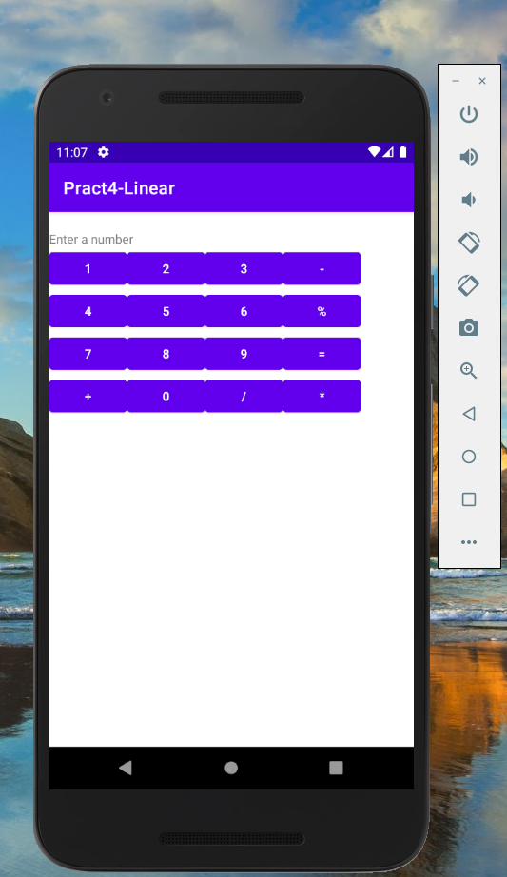

1. **Relative Layout:**

**activity_main.xml:**

<?xml version="1.0" encoding="utf-8"?>  
<RelativeLayout  
 xmlns:android="http://schemas.android.com/apk/res/android"  
 xmlns:app="http://schemas.android.com/apk/res-auto"  
 xmlns:tools="http://schemas.android.com/tools"  
 android:layout_width="match_parent"  
 android:layout_height="match_parent"  
 tools:context=".MainActivity">  
<EditText  
 android:id="@+id/editText"  
 android:layout_width="wrap_content"  
 android:layout_height="wrap_content"  
 android:ems="10"  
 android:inputType="textPersonName"  
 android:hint="User ID"  
 android:layout_marginTop="120dp"  
 android:layout_centerHorizontal="true"  
 />  
<EditText  
 android:id="@+id/editText2"  
 android:layout_width="wrap_content"  
 android:layout_height="wrap_content"  
 android:ems="10"  
 android:inputType="textPersonName"  
 android:hint="Password"  
 android:layout_below="@id/editText"  
 android:layout_centerHorizontal="true"  
 android:layout_marginTop="20dp"/>  
<Button  
 android:id="@+id/b1"  
 android:layout_width="wrap_content"  
 android:layout_height="wrap_content"  
 android:layout_below="@id/editText2"  
 android:layout_alignParentLeft="true"  
 android:layout_marginLeft="102dp"  
 android:layout_marginTop="14dp"  
 android:text="Log In" />  
<Button  
 android:id="@+id/b2"  
 android:layout_width="wrap_content"  
 android:layout_height="wrap_content"  
 android:layout_below="@id/editText2"  
 android:layout_alignParentRight="true"  
 android:layout_marginTop="20dp"  
 android:layout_marginRight="99dp"  
 android:text="Back" />  
</RelativeLayout>

**MainActivity.kt:**

package com.example.pract4_relative  
import androidx.appcompat.app.AppCompatActivity  
import android.os.Bundle  
import android.widget.Button  
import android.widget.EditText  
class MainActivity : AppCompatActivity() {  
 override fun onCreate(savedInstanceState: Bundle?) {  
 super.onCreate(savedInstanceState)  
 setContentView(R.layout.activity_main)  
 var btnLog=findViewById<Button>(R.id.b1)  
 var e1=findViewById<EditText>(R.id.editText)  
 var e2=findViewById<EditText>(R.id.editText2)  
 btnLog.setOnClickListener {  
 }  
 }  
}

**activity_main2.xml:**

<?xml version="1.0" encoding="utf-8"?>  
<RelativeLayout  
 xmlns:android="http://schemas.android.com/apk/res/android"  
 xmlns:app="http://schemas.android.com/apk/res-auto"  
 xmlns:tools="http://schemas.android.com/tools"  
 android:layout_width="match_parent"  
 android:layout_height="match_parent"  
 tools:context=".MainActivity2">  
 <TextView  
 android:id="@+id/textView"  
 android:layout_width="wrap_content"  
 android:layout_height="wrap_content"  
 android:text="Welcome"  
 android:layout_centerHorizontal="true"  
 android:textSize="50sp"/>  
</RelativeLayout>

**MainActivity2.kt:**

package com.example.pract4_relative  
import androidx.appcompat.app.AppCompatActivity  
import android.os.Bundle  
class MainActivity2 : AppCompatActivity() {  
 override fun onCreate(savedInstanceState: Bundle?) {  
 super.onCreate(savedInstanceState)  
 setContentView(R.layout.activity_main2)  
 }  
}

**Output:**

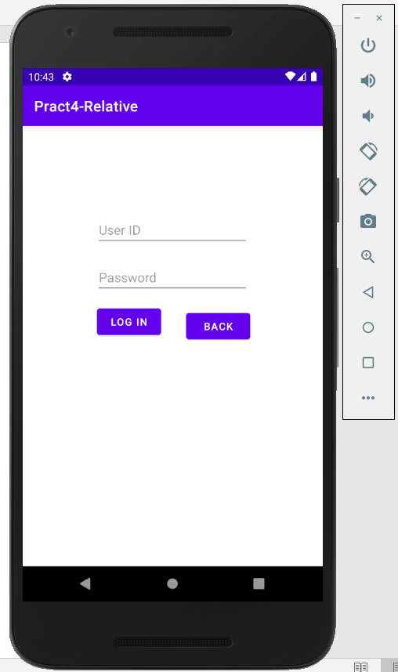

1. **Table Layout:**

**activity_main.xml:**

<?xml version="1.0" encoding="utf-8"?>  
<TableLayout  
 xmlns:android="http://schemas.android.com/apk/res/android"  
 xmlns:app="http://schemas.android.com/apk/res-auto"  
 xmlns:tools="http://schemas.android.com/tools"  
 android:layout_width="match_parent"  
 android:layout_height="match_parent"  
 tools:context=".MainActivity">  
<TableRow

android:layout_marginTop="20dp"  
 android:layout_marginLeft="20dp">

<TextView  
 android:id="@+id/t_uid"  
 android:layout_width="wrap_content"  
 android:layout_height="wrap_content"  
 android:layout_column="1"  
 android:text="User ID" />  
 <EditText  
 android:id="@+id/uname"  
 android:layout_width="wrap_content"  
 android:layout_height="wrap_content"  
 android:layout_column="2"  
 android:ems="10"  
 android:inputType="textPersonName" />  
 </TableRow>

<TableRow  
 android:layout_marginLeft="20dp">

<TextView  
 android:id="@+id/textView2"  
 android:layout_width="wrap_content"  
 android:layout_height="wrap_content"  
 android:layout_column="1"  
 android:text="Password" />  
 <EditText  
 android:id="@+id/editText2"  
 android:layout_width="wrap_content"  
 android:layout_height="wrap_content"  
 android:layout_column="2"  
 android:ems="10"  
 android:inputType="textPersonName" />  
 </TableRow>  
 <TableRow  
 android:layout_marginLeft="20dp">  
 <Button  
 android:id="@+id/button"  
 android:layout_width="wrap_content"  
 android:layout_height="wrap_content"  
 android:layout_column="1"  
 android:text="Login" />

<Button  
 android:id="@+id/button2"  
 android:layout_width="wrap_content"  
 android:layout_height="wrap_content"  
 android:layout_column="2"  
 android:text="Cancel" />  
 </TableRow>  
</TableLayout>

**MainActivity.kt:**

package com.example.tablefdemo  
import androidx.appcompat.app.AppCompatActivity  
import android.os.Bundle  
class MainActivity : AppCompatActivity() {  
 override fun onCreate(savedInstanceState: Bundle?) {  
 super.onCreate(savedInstanceState)  
 setContentView(R.layout.activity_main)  
 }  
}

**Output:**

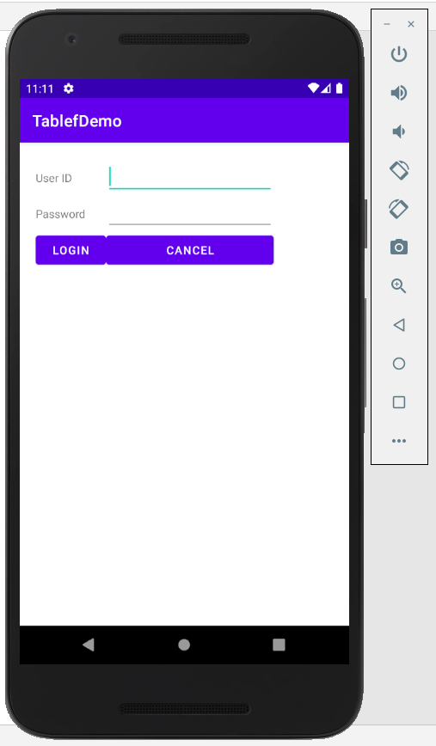

1. **Absolute Layout:**

**activity_main.xml:**

<?xml version="1.0" encoding="utf-8"?>  
<AbsoluteLayout  
 xmlns:android="http://schemas.android.com/apk/res/android"  
 xmlns:app="http://schemas.android.com/apk/res-auto"  
 xmlns:tools="http://schemas.android.com/tools"  
 android:layout_width="match_parent"  
 android:layout_height="match_parent"  
 tools:context=".MainActivity">  
<EditText  
 android:id="@+id/uname"  
 android:layout_width="wrap_content"  
 android:layout_height="wrap_content"  
 android:layout_x="70dp"  
 android:layout_y="100dp"  
 android:ems="10"  
 android:inputType="textPersonName"  
 android:hint="Username" />  
<EditText  
 android:id="@+id/passw"  
 android:layout_width="wrap_content"  
 android:layout_height="wrap_content"  
 android:layout_x="70dp"  
 android:layout_y="150dp"  
 android:ems="10"  
 android:inputType="textPersonName"  
 android:hint="Password" />  
<Button  
 android:id="@+id/button"  
 android:layout_width="wrap_content"  
 android:layout_height="wrap_content"  
 android:layout_x="69dp"  
 android:layout_y="202dp"  
 android:text="Login" />  
<Button  
 android:id="@+id/button2"  
 android:layout_width="wrap_content"  
 android:layout_height="wrap_content"  
 android:layout_x="185dp"  
 android:layout_y="203dp"  
 android:text="Cancel" />  
</AbsoluteLayout>

**MainActivity.kt:**

package com.example.absolutelayout  
import androidx.appcompat.app.AppCompatActivity  
import android.os.Bundle  
class MainActivity : AppCompatActivity() {  
 override fun onCreate(savedInstanceState: Bundle?) {  
 super.onCreate(savedInstanceState)  
 setContentView(R.layout.activity_main)  
 }  
}

**Output:**

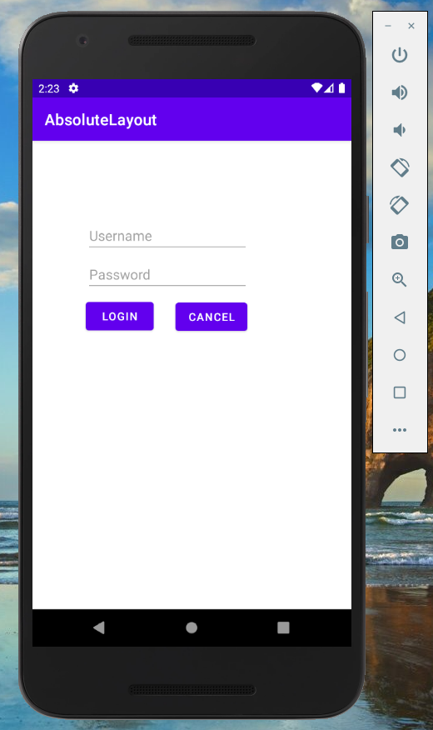

1. **Frame Layout:**

**activity_main.xml:**

<?xml version="1.0" encoding="utf-8"?>  
<FrameLayout  
 xmlns:android="http://schemas.android.com/apk/res/android"  
 xmlns:app="http://schemas.android.com/apk/res-auto"  
 xmlns:tools="http://schemas.android.com/tools"  
 android:layout_width="match_parent"  
 android:layout_height="match_parent"  
 tools:context=".MainActivity">  
 <ImageView  
 android:id="@+id/imageView"  
 android:layout_gravity="center"  
 android:layout_width="wrap_content"  
 android:layout_height="wrap_content"  
 app:srcCompat="@drawable/noddy" />  
<TextView  
 android:id="@+id/textView"  
 android:layout_width="wrap_content"  
 android:layout_height="wrap_content"  
 android:layout_gravity="center"  
 android:text="Noddy"  
 android:textSize="20sp" />  
</FrameLayout>

**MainActivity.kt:**

package com.example.framelayout  
import androidx.appcompat.app.AppCompatActivity  
import android.os.Bundle  
class MainActivity : AppCompatActivity() {  
 override fun onCreate(savedInstanceState: Bundle?) {  
 super.onCreate(savedInstanceState)  
 setContentView(R.layout.activity_main)  
 }  
}

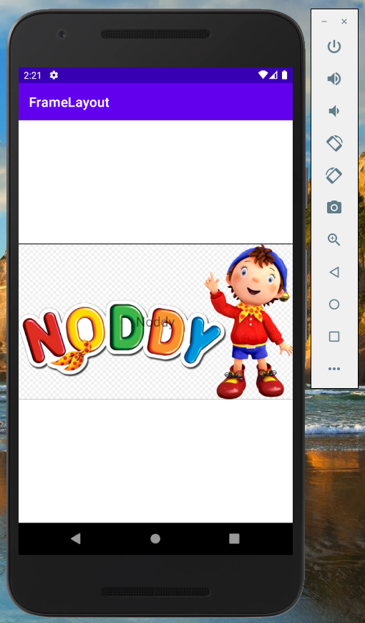**Output:**